GUI Printouts for Holiday Movies and Music Store  
Ryu Muthui  
Nasir Elmi  
Gil Chavez  
Jan Kruschewski  
CS115 Section B  
December 07, 2012

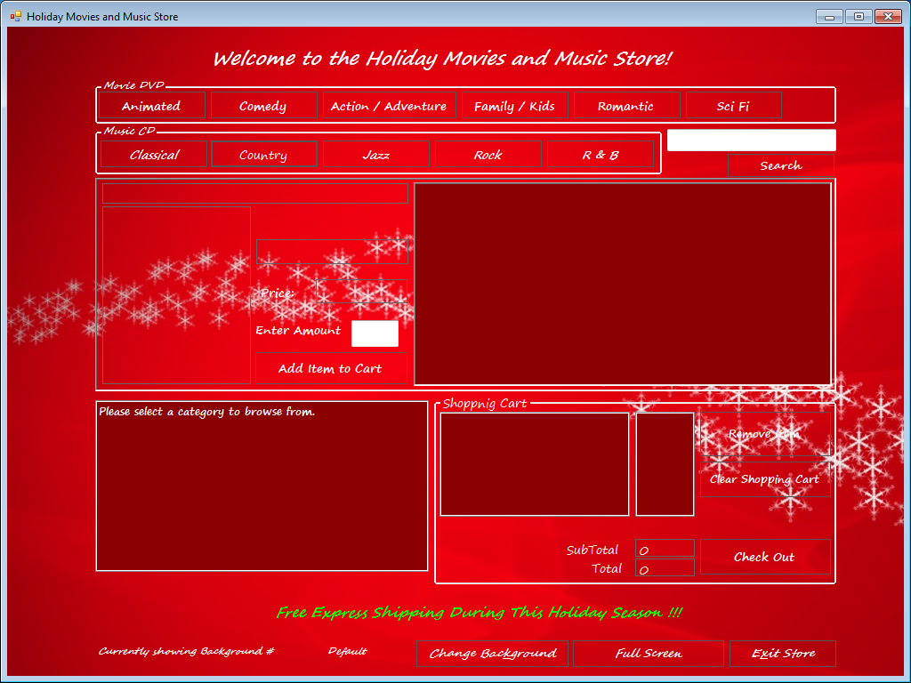  
This is the GUI as it first comes up.

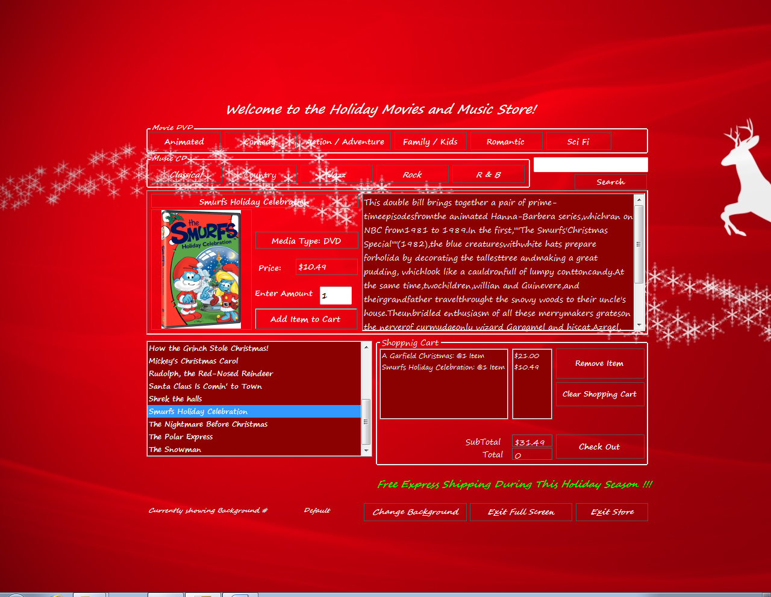  
This is the GUI with the Full Screen Feature applied.  
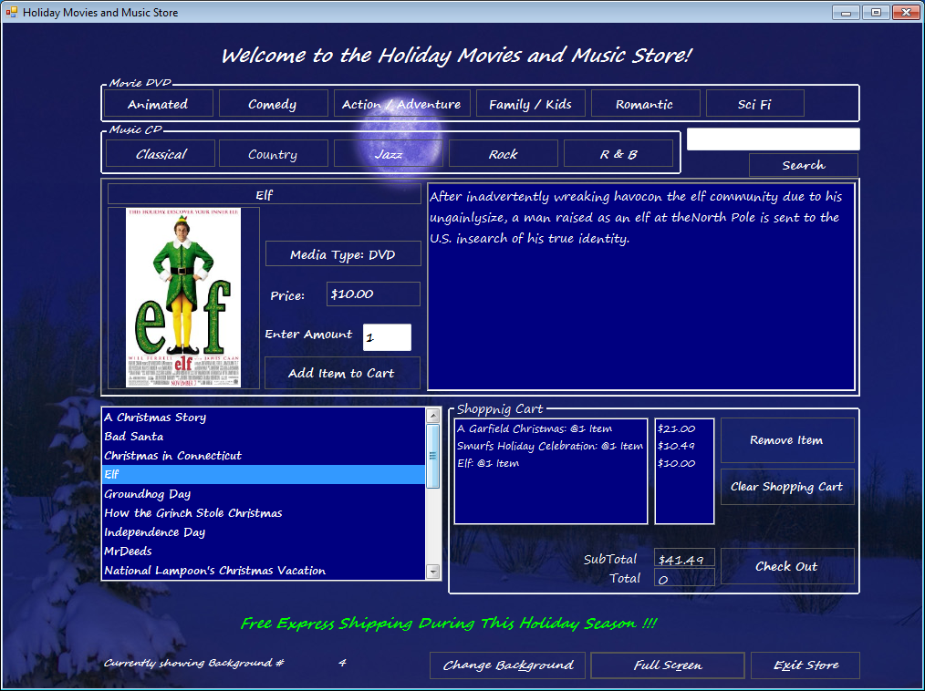  
This is the GUI with different back ground working.

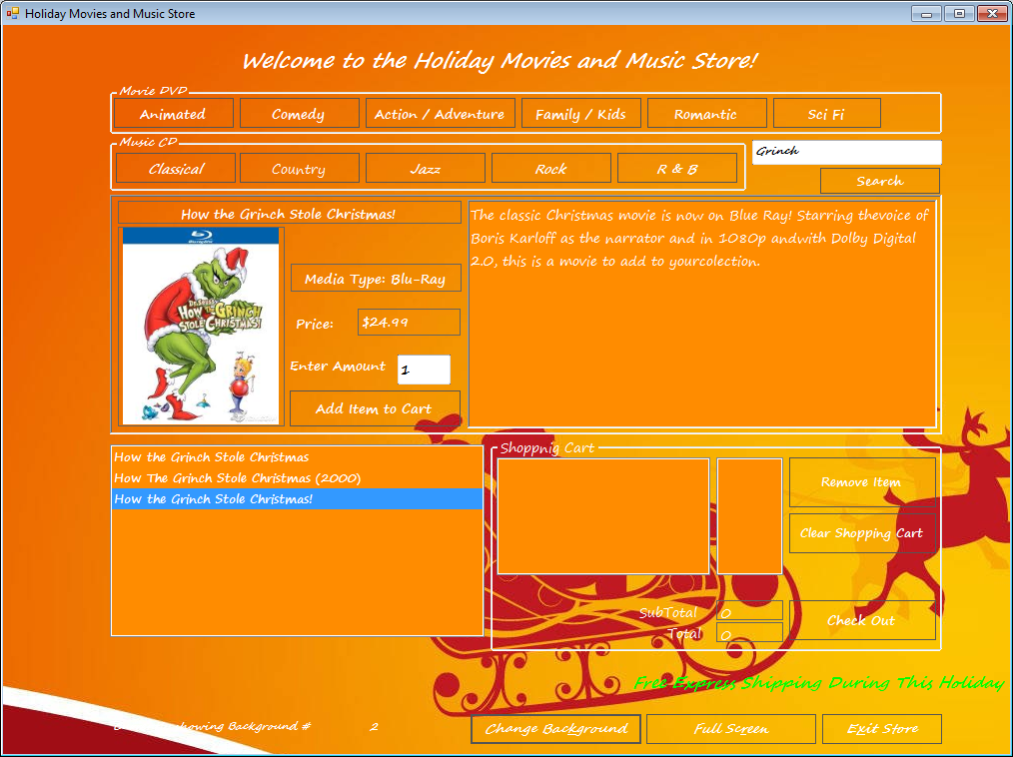  
This is the GUI with the Search Bar feature applied.

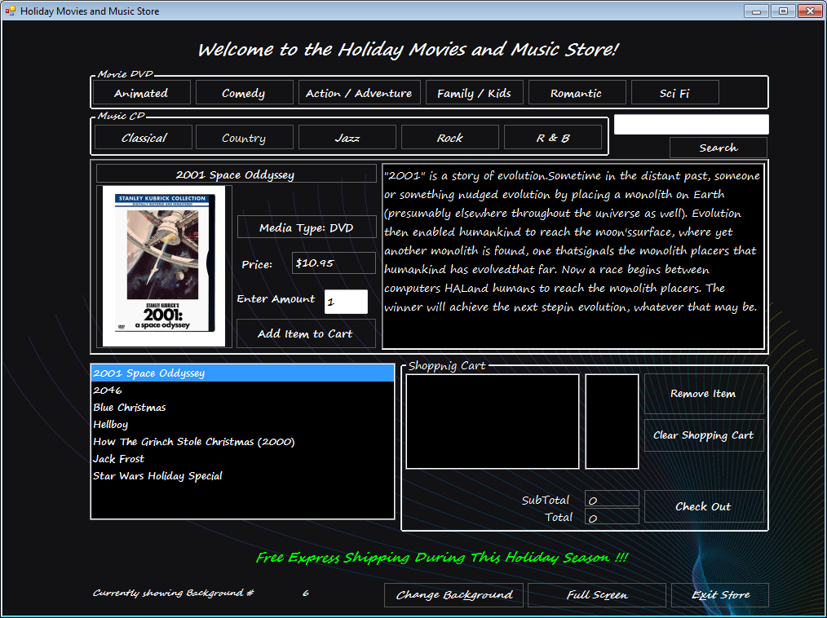  
This is the GUI with the scrolling banner at the bottom of the screen around the center.